MG Spreading System Case Study | Spreading Pesticide and Fertilizer in Linyi, Shandong

Flowing through China’s northeastern city of Linyi, the Yi river is the main waterway of the region, irrigating over 131 thousand acres of rice paddies.
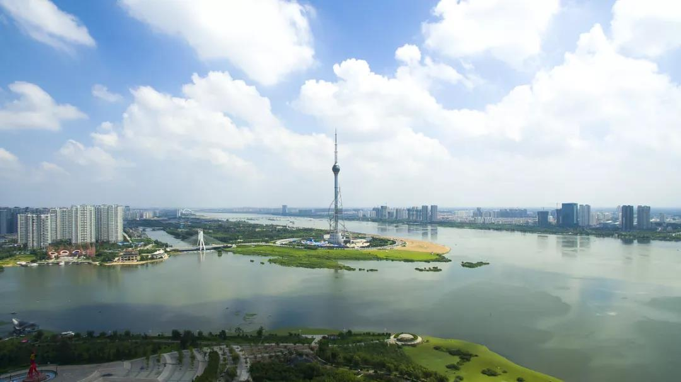
The treatment of these fields traditionally involves manual topdressing and pest control at the later stage of the rice planting process. This labor-intensive process is often inefficient, and any delays would prove a detriment to the harvest. Recent years have also seen a decrease in labor opportunities in rural areas and an increase in operational costs, further restricting seasonal profits.

Improving rice yield requires multiple factors such as reducing pesticide application at the late stage of rice growth, lowering labor costs, increasing worker motivation. To accomplish these, Jiajian Agriculture Co., Ltd began exploring methods of efficiency, including a method that combines pesticide and fertilizer distribution into one process.

With local conditions in mind, Jiajian Agriculture decided to employ drone technology to distribute a new mixture of fertilizer, slow-release urea, and thiamethoxam. This mixture promotes crop growth with a mixture of nitrogen, zinc, magnesium, and boron, as well as controls pests such as planthoppers.

Jing Yang, business manager for Jiajian Agriculture, has extensive experience mixing agricultural materials, and has long considered a mixture of pesticide and fertilizer. Unfortunately, limitations in equipment prevented him from distributing the combination evenly. That is until he found out about the DJI MG series. With its official launch, Jing Yang was finally able to put his theories into practice.

Learning about the specifications of the MG series, Jing Yang contacted the Shandong dealer for DJI Agriculture, who arrived to conduct an aerial spraying of the pesticide and fertilizer mixture.

After the demonstration, Jing Yang explained the results in detail.
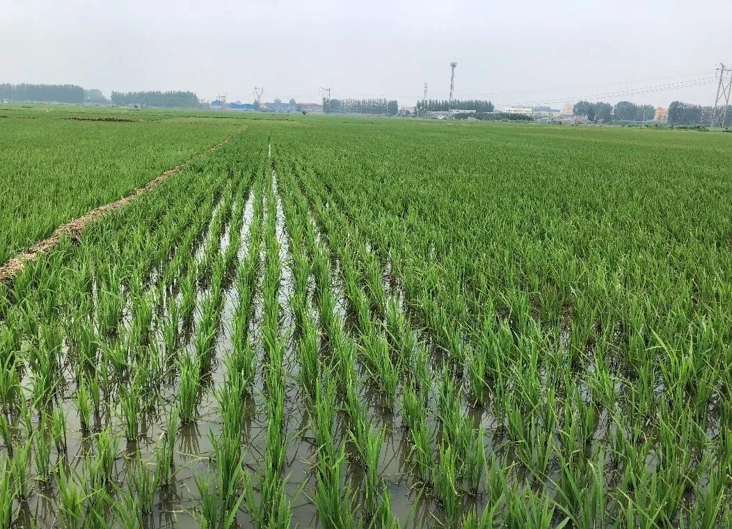

In this demonstration, Jing Yang selected a 0.66-acre rice field in the Xu-Tai-Ping Village of Hedong District, used the Linyi No. 16 rice and transplanted them for 10 days, starting on July 5, 2018.

Shanghai Yue-Wei Plant Nutrition Technology Co., Ltd developed the special fertilizer, which supplements the elements that are easily missing during rice planting, according to the characteristics of rice growth. Luxi Chemical Corp. developed the urea, a slow-release type that can effectively and continuously supplement nitrogen. Shanghai Hulian Bio-Pharmaceutical Co., Ltd developed the thiamethoxam, which can effectively control pests such as rice planthoppers.

Materials | Type | Dosage per acre
Dao Feng Fertilizer | Particles | 3 kg
Urea | Particles | 9 kg
Dao Huang Jin | Particles | 200 g

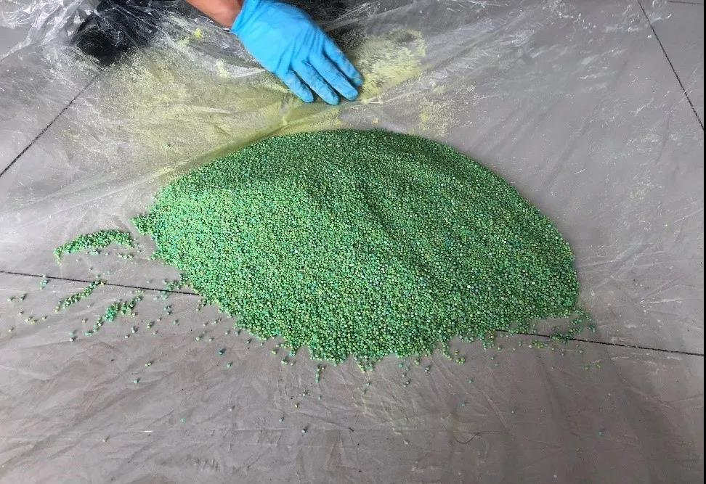
The fertilizer and pesticide mixture

The spraying specifications below are in accordance with the characteristics of the rice field and pesticide/fertilizer mixture
Dosage per acre | 15 KG | Flight Altitude | 2 M
Flying Speed | 4 m/s | Horizontal distance | 5 M
Spraying opening | 50% | Rotary speed | 700 rpm
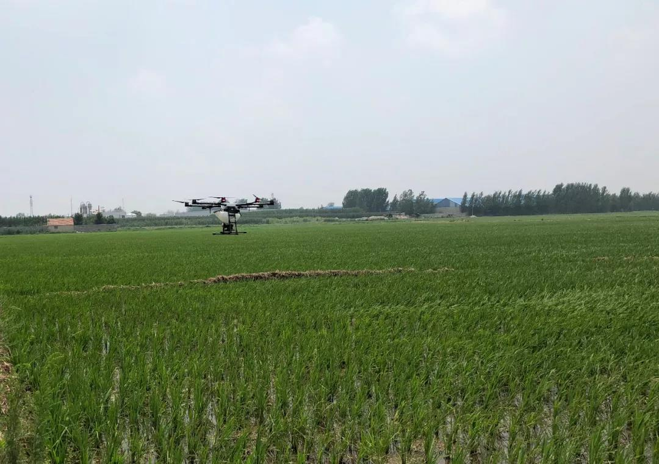
Distribution in the field after spraying

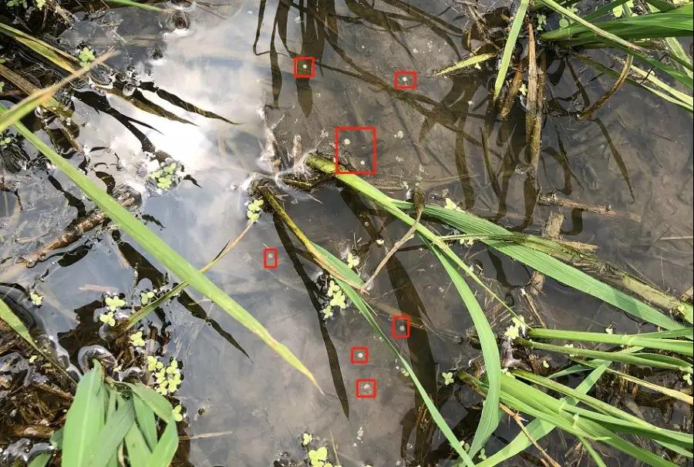

After the spraying was complete, the farmers satisfied to see the particles distributed evenly in the field. Jing Yang concluded that UAV spraying can greatly reduce labor and operation costs. Long-term effects are subject to further observation. If it is possible, he plans to apply aerial spraying in all his fields next year.

For Jing Yang, this demonstration is of great significance. Successful spraying of pesticide and fertilizer can help develop the local rice market and replace traditional manual spraying methods. He is confident about the future application of aerial spraying.
